Hey team ,
For today’s hands-on challenge, Those who completed the Ansible videos and Tasks I’d like to work on Ansible role creation and lifecycle management.Please complete the tasks below:
 Challenge – Ansible Roles (Nginx, HTTPD, Tomcat)
Create the following roles with proper structure, templates, handlers, and lifecycle tasks: Nginx Role
- Install and configure Nginx using templates.
- Include handlers for: install, start, restart, stop, remove.
- Add role dependencies using meta/main.yml.
- Add and use tags effectively throughout the role.
- Simulate publishing this custom Nginx role to Ansible Galaxy (provide steps or dummy content).

## Prerequisites

* Ansible installed (>= 2.9 recommended)
* Sudo privileges on the target machine (for localhost run)
* Role folder located at `roles/nginx/` inside your playbook directory (`/root/ansible/playbooks/nginx/` in examples)

---

## Directory structure -- > run this command : ansible-galaxy init nginx
You will al the directories by default from ansible aand modify it accordingly
Place this role at `roles/nginx/`. Example tree:

```
roles/nginx/
├── defaults/
│ └── main.yml
├── handlers/
│ └── main.yml
├── meta/
│ └── main.yml
├── tasks/
│ ├── main.yml
│ ├── install.yml
│ ├── configure.yml
│ └── service.yml
├── templates/
│ └── nginx.conf.j2
└── vars/
└── main.yml
```

---

## 1. defaults/main.yml

Path: `roles/nginx/defaults/main.yml`

```yaml
---
# Default variables for nginx role (can be overridden)
nginx_package: nginx
nginx_service: nginx
nginx_user: nginx
nginx_worker_processes: auto
nginx_worker_connections: 1024
nginx_listen_port: 80
nginx_conf_path: /etc/nginx/nginx.conf
```
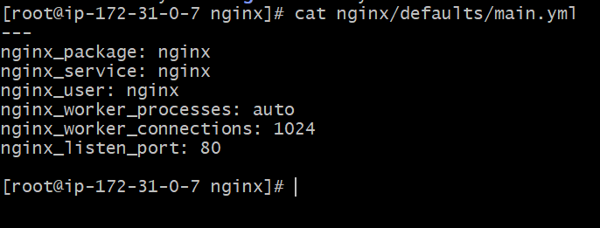
## 2. vars/main.yml (optional)

Path: `roles/nginx/vars/main.yml`

```yaml
---
# OS-specific or sensitive constants (optional)
# If you don't need OS-specific overrides, you may leave this empty
```

---

## 3. handlers/main.yml

Path: `roles/nginx/handlers/main.yml`
# handlers file for nginx
- name: restart nginx
service:
name: "{{ nginx_service }}"
state: restarted

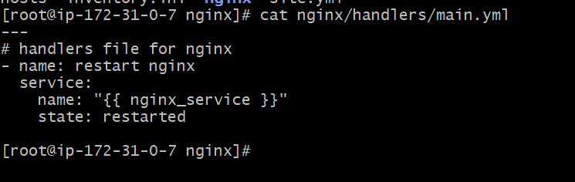
> Note: `meta: noop` used for the `install nginx` handler to keep it explicit; the actual package task can notify this handler or you can remove the noop and call a package module there.

---

## 4. tasks/main.yml
# tasks file for nginx
- include_tasks: install.yml
- include_tasks: configure.yml
- include_tasks: service.yml

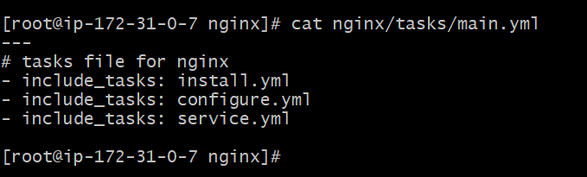
## 5. tasks/install.yml

Path: `roles/nginx/tasks/install.yml`

```yaml
---- name: Install nginx
package:
name: "{{ nginx_package }}"
state: present
notify: restart nginx

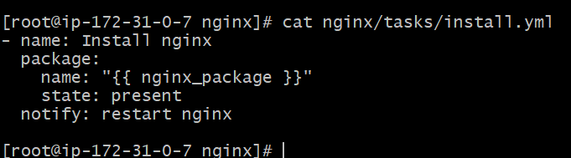

## 6. tasks/configure.yml

Path: `roles/nginx/tasks/configure.yml`
- name: Configure nginx
template:
src: nginx.conf.j2
dest: /etc/nginx/nginx.conf
notify: restart nginx

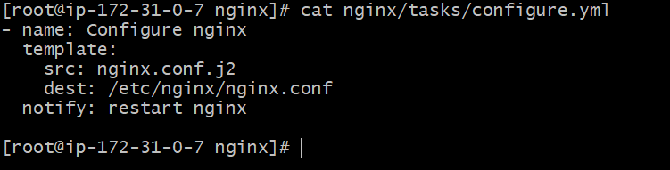
---

## 7. tasks/service.yml

Path: `roles/nginx/tasks/service.yml`

```yaml
---
- name: Ensure nginx is started and enabled
service:
name: "{{ nginx_service }}"
state: started
enabled: true
notify:
- start nginx
tags: [nginx, service, start]

- name: Stop nginx (explicit)
service:
name: "{{ nginx_service }}"
state: stopped
tags: [nginx, service, stop]
```

---

## 8. templates/nginx.conf.j2

Path: `roles/nginx/templates/nginx.conf.j2`

```jinja2
user {{ nginx_user }};
worker_processes {{ nginx_worker_processes }};

error_log /var/log/nginx/error.log warn;
pid /run/nginx.pid;

events {
worker_connections {{ nginx_worker_connections }};
}

http {
include /etc/nginx/mime.types;
default_type application/octet-stream;

log_format main '$remote_addr - $remote_user [$time_local] "$request" '
'$status $body_bytes_sent "$http_referer" '
'"$http_user_agent" "$http_x_forwarded_for"';

access_log /var/log/nginx/access.log main;

sendfile on;
keepalive_timeout 65;

server {
listen {{ nginx_listen_port }};
server_name _;

location / {
return 200 'Hello from Ansible Nginx role!';
}
}
}
```

---

## 9. meta/main.yml

Path: `roles/nginx/meta/main.yml`

```yaml
---
galaxy_info:
author: your_name
description: Custom Nginx role for installation and configuration
company: ExampleCorp
license: MIT
min_ansible_version: 2.9
platforms:
- name: Ubuntu
versions: [focal, jammy]
- name: CentOS
versions: ['7', '8']

dependencies: []
```

---

## 10. site.yml (top-level playbook)

Path: `site.yml` (project root)

```yaml
---
- name: Run Nginx role locally
hosts: webservers
become: true
roles:
- role: nginx
tags: [nginx]
```

---

## 11. inventory.ini (local run)

Path: `inventory.ini` (project root)

```ini
[webservers]
localhost ansible_connection=local ansible_python_interpreter=/usr/bin/python3
```

> Adjust `ansible_python_interpreter` if your local Python3 path differs (for example `/usr/bin/python3` or `/usr/local/bin/python3`).

---

## 12. Commands — syntax check and run

**Syntax check:**

```bash
ansible-playbook -i inventory.ini site.yml --syntax-check
```

**Run the playbook:**

```bash
ansible-playbook -i inventory.ini site.yml
```

**Run only install steps (tags):**

```bash
ansible-playbook -i inventory.ini site.yml --tags install
```

**Skip service steps:**

```bash
ansible-playbook -i inventory.ini site.yml --skip-tags service
```

**More verbose output for debugging:**

```bash
ansible-playbook -i inventory.ini site.yml -vvv
```

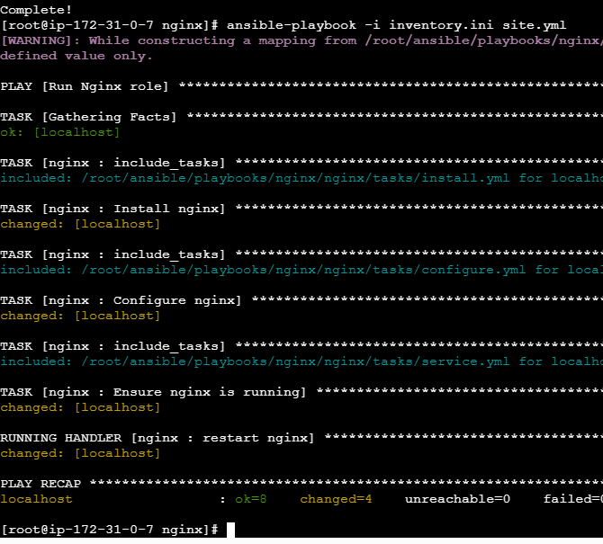

 HTTPD Role
- Create a full role to configure Apache HTTPD.
- Use templates for configuration and virtual hosts.
- Include lifecycle actions: install/start/restart/stop/remove.
httpd/
├── defaults/main.yml
├── handlers/main.yml
├── meta/main.yml
├── tasks/main.yml
├── templates/
├── vars/main.yml
└── files/
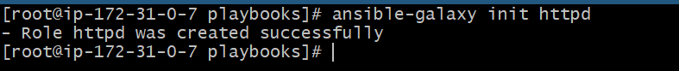
Vi httpd/defaults/main.yml
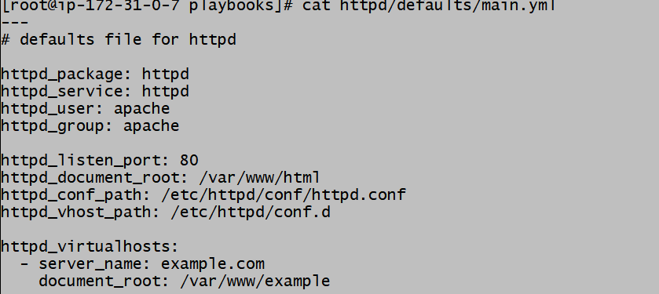

Vi httpd/handlers/main.yml

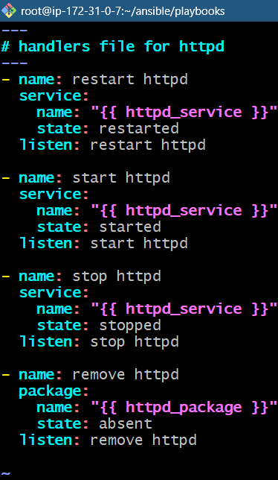

Vi httpd/tasks/main.yml
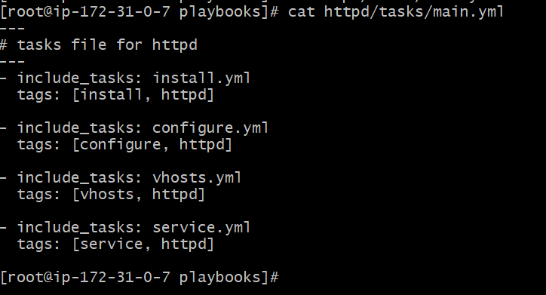
Vi httpd/task/install.yml
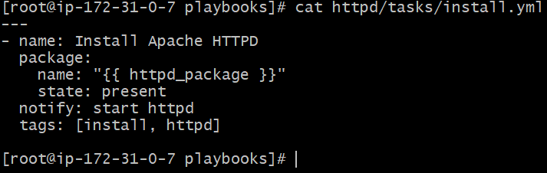
Vi httpd/tasks/configure.yml
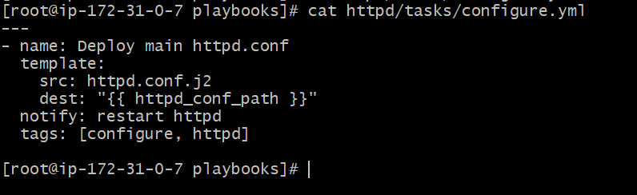
Vi httpd/tasks/vhosts.yml

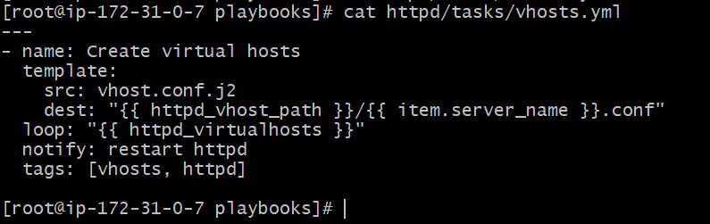
Vi httpd/tasks/service.yml
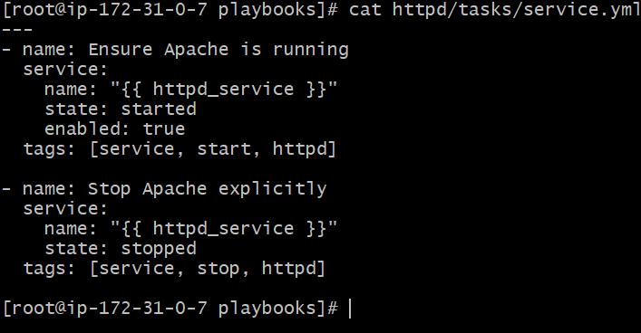
Vi httpd/templates/htttpd.conf.j2
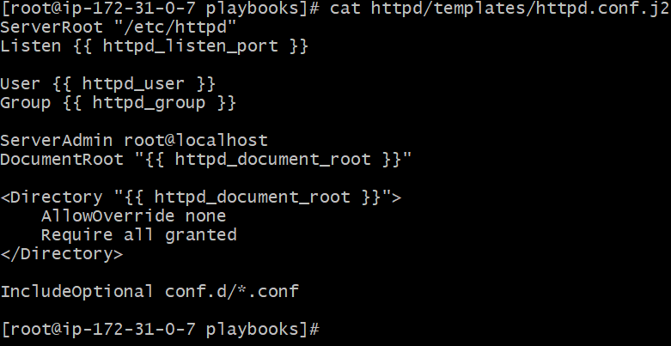

Vi httpd/templates/vhosts.conf.j2
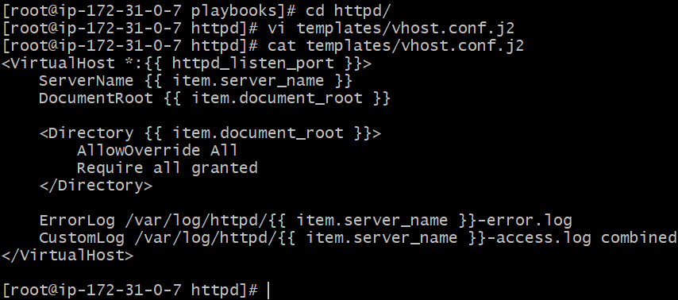
Vi httpd/meta/main.yml
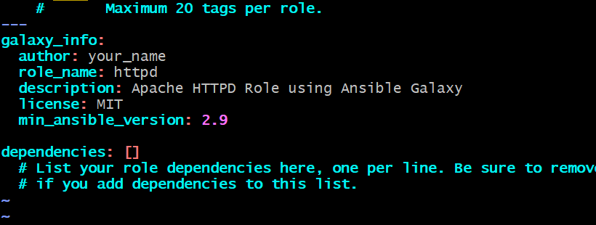
Vi site.yml
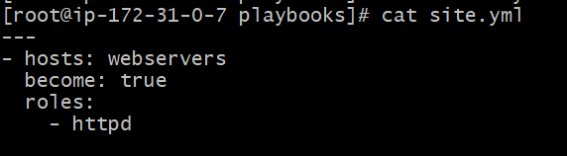
Vi inventory.yml
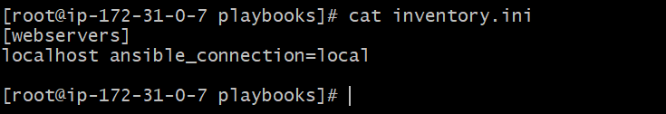

 Tomcat Role
- Build a full Tomcat configuration role.
- Manage service, ports, and configuration.
- Include lifecycle actions: install/start/restart/stop/remove.
 Deliverables
- A well-structured Ansible role directory for each service.
- A working example playbook to test each role.
- A short README describing functionality and variables.

